Autonomous Database
By Kamryn Vinson.
Architectural components and key features.
After our time together is up, you should be able to define the architectural components of Autonomous Database (ADP) and its key features.
The biggest benefit is the massive decrease in time spent managing databases. ADB eliminates the complexity of operating and securing Oracle Database while giving customers the highest level of performance, scalability, and availability. availability.
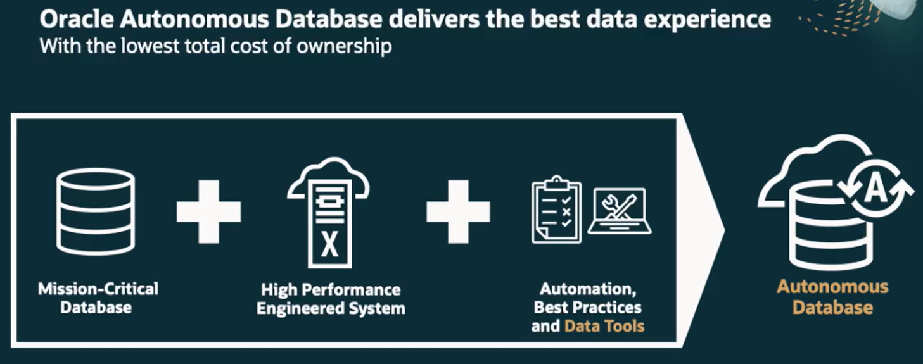
Administering a mission -critical database is traditionally very expensive because it requires manual provisioning, securing, monitoring, patching, backing up, upgrading and recovering,
troubleshooting, testing, and tuning of a complex, highly available scale-out deployment with disaster recovery protection.
The extensive automation provided by the Autonomous Database dramatically simplifies these tasks, reducing administration costs by up to 80%New application development offer suffers for many months of delays waiting for database provisioning, testing, and tuning.
With the Autonomous Database, new applications don't wait at all, saving tens of thousands of dollars per application and enabling much faster innovation.
Incremental changes around the edges aren't enough to answer these challenges. Even moving the entire enterprise computing estate to the cloud is only a partial solution,
because this just shifts many of the same management difficulties to a different infrastructure.
Instead, IT leaders need to strike at the heart of the matter, rethink data management for a cloud-native world. They need data management that can manage on its own the core activities of performance, security, and availability.
This new approach to data management has to make data appear as if it were stored in a shape and made available at a scale ideal for the current workload,
without having to predict it ahead of time. To deliver data management as a service like this, IT leaders need a new kind of database.
Downtime for critical applications causes severe financial and reputational damage. IT leaders must be sure that the cloud architecture they adopt handles every threat to availability, from software and hardware failures and maintenance to natural disasters.
The Autonomous Database is more reliable than a manually operated database. At startup, it automatically establishes a triple mirrored scale-out configuration in one regional cloud data center, with an optional full standby copy in another region.
The Autonomous Database automatically recovers from any physical failures, whether at the server or data center level. The Autonomous Databases fault-tolerant scale-out cluster that works transparently for both OLTP and analytic workloads makes it uniquely capable of running mission-critical workloads.
We've touched on ADB features, let's talk about them a bit more. Like an autonomous car. Oracle Autonomous Database provides a level of performance and reliability that manually-managed databases can't deliver. It can provision, secure, and manage in a way manual databases can't. Let's look at provision.
Oracle quickly deploys a mission-critical database on our Exadata Infrastructure Cloud, a platform optimized for Oracle Database. The database is created as a rack cluster, so it can scale out seamlessly, but also protect the database in case of a server failure. In order to protect the system against a complete failure, we also create a standby system using Autonomous Data Guard in the same region or a different region in the cloud to protect against regional failures.
Once provisioned, the system needs to be secured by default. We encrypt all the data in the database, but encrypting the data at REST is not enough. All connections to the database are fully encrypted too. To ensure systems are not exposed to any security vulnerabilities, we also apply all security patches as soon as they are available.
Manage the system. So Oracle applies all the OS, storage, VM, and database patches, plus we diagnose all problems. We use machine learning to help us detect and diagnose errors. ADB detects and protects from system failures and user errors automatically, and provides failover to standby databases with 0 data loss.
It provisions highly available databases, configures and tunes for specific workloads, and scales compute resources when needed, all done automatically to enable true pay-per-use.
Without human detection. ADB uses indexes, optimizer statistics, and plans, and optimize data formats to run the workloads and achieve the best performance. ADB ushers in a new era in data management, radically changing the way companies deal with database and data management in general. This new class of databases is based on the world's most secure, available, performant, and reliable database, Exadata. This new era is available both in the public cloud and on premises. The largest enterprises and governments already run their mission-critical workloads with Oracle Database on Exadata. ADB offers them the safest transition to the cloud.

Autonomous Database offerings.
By Kay Malcolm. VP of Product Management.
The Autonomous Database completely revolutionizes data management. It allows you to focus on innovating your business and designing and developing new features and functions without having to worry about the full stack administration costs. We provide the ability to service, maintain, and manage the underlying infrastructure on which your data workload is running, so that you can focus on innovating and working on your application requirements.
Now we also ensure data safety by eliminating many cyber-attack vulnerabilities. We're also able to meet service level objectives of 99.95% availability.
Now, that's quite a tall order for a new product until you realize that we've been on this journey for over 20 years. See, starting in Oracle Database 9i, we began to introduce and mature many sophisticated automation capabilities, from memory management, workload monitoring, and tuning, all of which are used in the Autonomous Database. Continuing to the release 21C and now to 23ai.
But it's not just the database management that Oracle has been automating. We have also spent the last decade working on the database infrastructure with our engineered systems, which provide the best platform for the Oracle Database because it's the only preconfigured, retested, and optimized platform for the database.
Oracle Autonomous Database is actually a family of cloud services, with each member of the family optimized to a specific workload. It's the same Autonomous Database regardless of the option you choose.
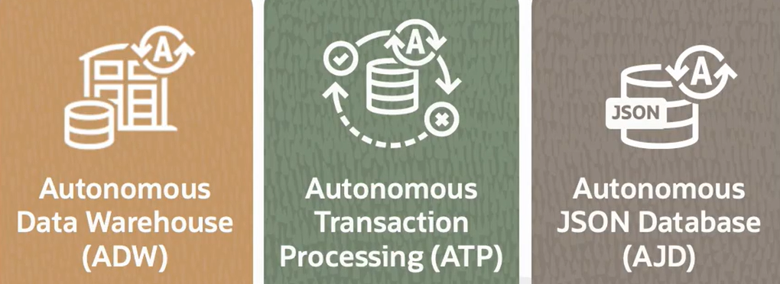
- 1st member: Autonomous Data Warehouse, or ADW, which has been optimized for analytic workloads like data warehouse, data marts, or as part of a data lake.
- 2nd member: Autonomous Transaction Processing, or ATP. ATP is optimized for transaction processing or mixed workload environments and makes an excellent platform for new app development.
- 3rd member: Autonomous JSON Database, or ADJ, natively supports JSON data allowing applications to store and retrieve JSON documents using SODA (Simple Oracle Document Access) as well as SQL queries to store and retrieve data stored in JSON formatted data.
ADB makes it easy to expose your data in business logic as RESTful endpoints, making it easily available to any application. Now you can also use the Oracle Database API for MongoDB to query and update collections, simplifying app development.
All members of the Autonomous Database family share the same feature set, including fully automated high performance Exadata infrastructure that provides world-class availability and scalability. They also share complete automation of all database admin tasks, things like provisioning, patching, securing backups, and so on. ATP only differs from ADW when it comes to how we optimize for each specific workload in the database. ADW is optimized for complex analytics, where ATP is optimized for high throughput transaction processing. Now with ADW, you get a subset of the database and memory capability and advanced analytics.
Now when you look at data organization and start loading data into the Autonomous Database, we store the data. By default in the appropriate format for each workload. If it's ADW, we store in a columnar format because that's the best format for analytical processing. If it's ATP, then we store that data in a row format as that's the best format for fast single row lookup.
In ADW when you're looking at data access, we use data summaries like storage indexes on the Exadata storage cells, and the result cache quickly accesses only the data needed to answer each query. In ATP, indexes are used to access only the rows or records needed for each transaction. For analytics workloads, we automatically parallelize the query execution to access large volumes of data in a short amount of time to answer business questions. If you're talking about a transaction processing system, then we automatically use indexes to quickly access the appropriate records.
We also detect missing indexes, and we create them for you. In ADW, the data set is far too large to cache, so memory is used to speed up large joins aggregations like group-bys. In ATP, we use the majority of the memory to cache the active data set to avoid any I/O. We also use RMA to access data directly in memory on the other servers in the RAC cluster.
The default way data is stored for a given table can be overridden within ADW and ATP. This allows flexibility to implement the type of data structure for your specific use. Now, regardless of the workload, we need to keep optimizer statistics current to ensure we get optimal execution plans. With ADW, we are able to achieve this by gathering statistics as part of all bulk load activities.
With ATP, where data is added using more traditional insert statements, statistics are automatically gathered periodically. As the data volumes change or new access structures are created, there is the potential for an execution plan to change, and any change could result in a performance regression. So, we use Oracle SQL plan management to ensure that plans only change for the better.
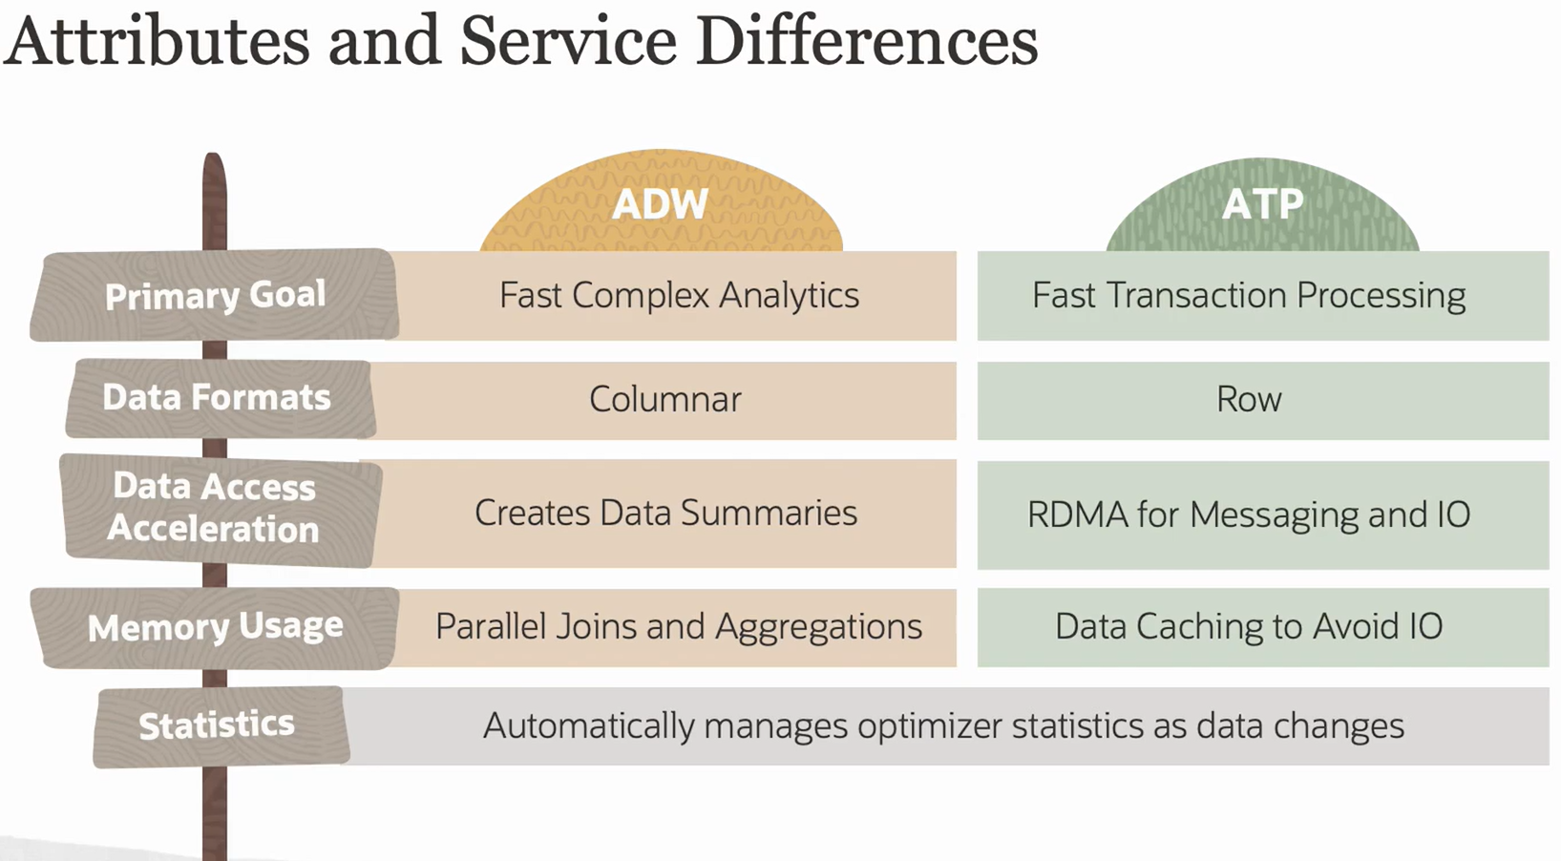
There are two physical deployment choices. There's one deployment choice that we have called ADP Serverless and the other is ADP Dedicated. The easiest way to think about this is that ADP Serverless is a very simple and elastic small footprint to large footprint version of ADB versus Dedicated Infrastructure, which is a customizable private database cloud in the public cloud.
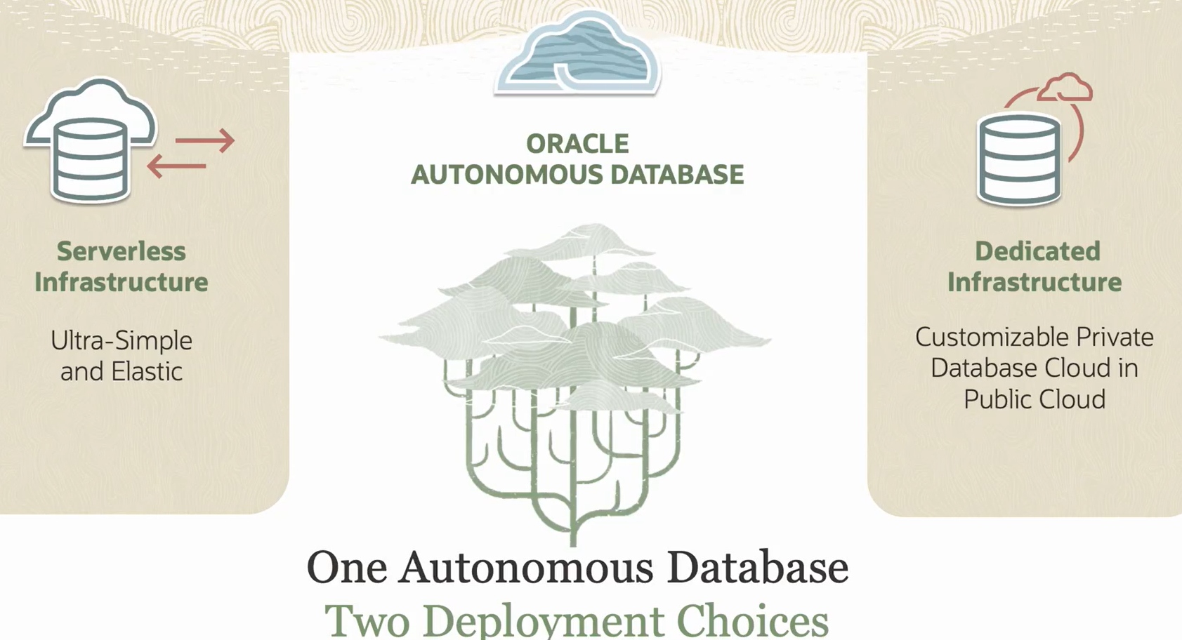
ADP Serverless fully automates the deployment of resources. It provides complete data protection and security and protects from system failures and user errors automatically and provides failover to standby databases with zero data loss. ADP Dedicated adds complete isolation of your compute and operations with a private dedicated database cloud within the public cloud. Dedicated system resources like processor, memory, network or storage offer greater control over operational policies and customizations.
To drill into this in more detail, the Serverless approach allows you to start with small, simple workloads. A workload that could run on a couple of cpus, for example, can definitely benefit from this. But it's not limited to small workloads, it's much more elastic. We can start with a couple of ECPUs and grow up to 512 ECPUs and higher, all automatically and dynamically. And we can start with as small as 1 terabyte of storage for data warehousing and 20 gigs for transaction processing. And we can go much, much farther than that, beyond hundreds of terabytes.
And we have a very low time commitment. We can actually commit less than an hour, and it can automatically scale online for true pay per use. It's also possible to stop the ADP Serverless service and not be billed for any ECPUs while that service is not running.
Dedicated, as I mentioned, runs on a fully dedicated Exadata infrastructure but in the public cloud. It can run all your databases, any size, scale or criticality, and it definitely provides the highest level of isolation because each one of your workloads is running within your own zone. And it's physically separated from other tenants.
Dedicated is definitely suitable for customers who have customizable operational requirements. You can control or you have more control over when the systems are provisioned, how your software is updated, as well as the availability and density of your servers that are being hosted in this Autonomous Database model.
--------------------------------------------------

Autonomous Database licensing
By Kamryn Vinson.
Oracle is offering an ECPU based pricing metric for the Autonomous Database.
What are ECPUs?
- They're an abstract compute metric of cloud resources that is performance-based
- They are elastically allocated from ADB's shared pool of Exadata Database and storage servers
- CPUs are not based on physical cores or threads
- Default compute model for all new ADB instances.
Benefits of ECPUs
- Provides a durable pricing metric that is not tied to the exact make, model, and clock speed of the underlying processor, which avoids pricing complexity as hardware systems change.
- Delivers competitive advantages for ADW
- They provide finer-granularity system sizing and auto scaling for ADW.
- Reduced storage costs for ADW instances using ECPU.
ECPU key points when discussing Autonomous Database pricing metrics.
- ECPU pricing is available for ADW and ATP with a minimum configuration of two ECPUs.
- Beyond two ECPUs, scaling is available in single step increments for maximum cost efficiency.
- Licensing for ECPUs can be:
  - Pay-As-You-Go
  - BYOL (Bring-Your-Own-License for existing Oracle Database customers). You also choose an Oracle Database Edition and the edition you select is based on the licenses you bring to Autonomous Database and changes the maximum value that you can select for the number of ECPUs.
When purchasing ADW or ATP, there are two pricing models.
- Your customer can use the universal credit model or UCM, which includes all database options.
- Or if the customer owns their Oracle Database licenses, they can use Bring-Your-Own-License or BYOL to reduce their cost.
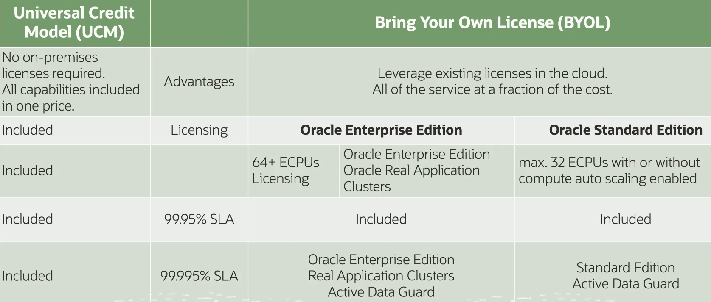
Advantages. When your customer obtains ADB licenses through the universal credit model, they can access all capabilities with standard pricing. If your customer leverages their existing Oracle licenses, they can pay a fraction of the UCM standard pricing.
Licensing. The standard UCM pricing does not require the customer to separately own Oracle licenses. BYOL pricing for provisioning instances with more than 64 ECPUs requires existing real application clusters licenses, in addition to the Oracle Enterprise Edition licenses.
BYOL pricing for standard edition restricts the number of ECPUs you can use to a maximum of 32 ECPUs, with or without compute autoscaling enabled.
99.995% service level agreement. If your customer requires a 99.995% SLA and is using Bring-Your-Own-License model, then they would need Oracle Enterprise Edition, Real Application Clusters, and Active Data Guard to achieve that level of service.
Oracle universal credit pricing is based on two distinct payment structures.
- 1st: Pay-As-You-Go (PAYG): unit cost structure that allows customers to quickly provision services and only pay for what they use. Unit costs are based on the type of service provided and includes the use of certain licenses, such as Oracle Database or database options, for example.
- 2nd: Annual universal credits. It's like a prepaid gift card, and the credits represent the amount of money that a customer is committed to spend per year on OCI. It's a one-year minimum commitment that enables customers to have the flexibility to use any OCI and platform services at any time in any region.
Customers can commit to an amount of Oracle annual universal credits that can be applied towards the future usage of eligible Oracle IaaS and PaaS cloud services. Customers can also receive a field discount depending on how much they commit to. It's a very straightforward way to do things and we don't touch anything that's running.
You can convert from BYOL to license required and also from license required to BYOL. Here's an example of a database that's running with Bring-Your-Own-License. Let's see how to toggle the license type from Bring-Your-Own-License to license included.
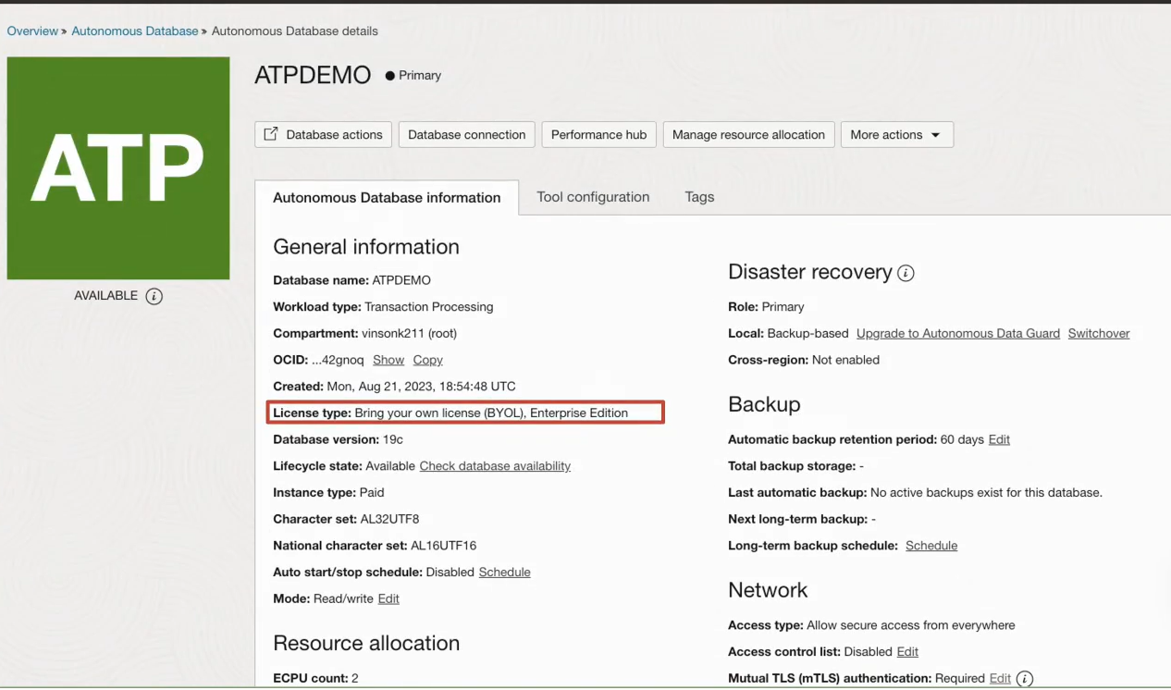
Now click the More Actions dropdown list. Then select Update License and Oracle Database edition. We're setting it to be subscribe to an Enterprise edition license included. Once we click Save.
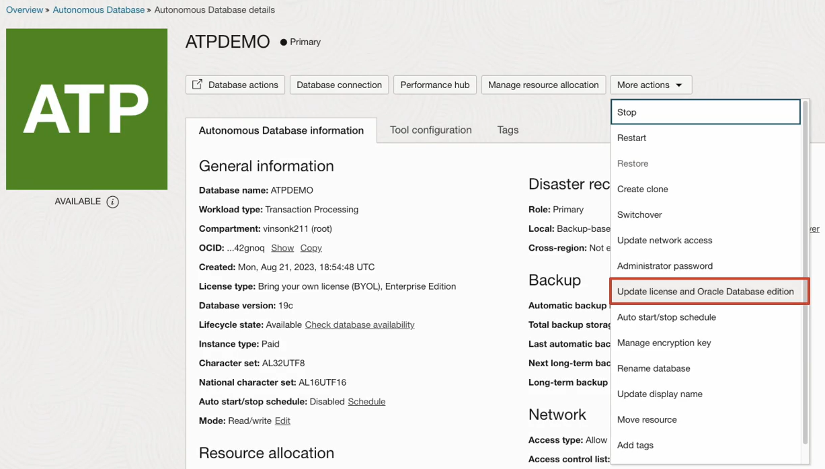
We're setting it to be subscribed to a regular Pay-As-You-Go license included billing model by toggling the radio button to disable BYOL. Once we click Save. The license type changes to license included, and this information is removed from the console. So it's possible to toggle between both types of licenses dynamically and on the fly without incurring any downtime.

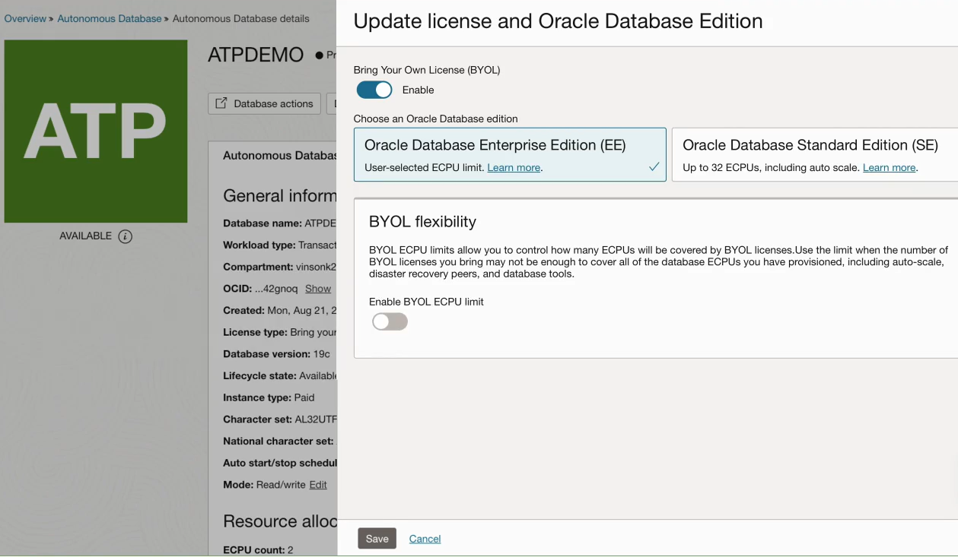
----------------------------------------------------------------------------------------------------------------------------------------------
OCI - Oracle Cloud Infrastructure
By Kay Malcolm, VP of product management
Some of the world's largest enterprises are running their mission-critical workloads on Oracle's next-generation Cloud platform called Oracle Cloud Infrastructure. In this lesson, you will see a general overview of what you can do in OCI.
To keep things simple, let's break them down into seven major categories:
- core infrastructure
- database services
- data and AI
- analytics
- governance and administration
- developer services
- and application services
We have building blocks on top of this global footprint.
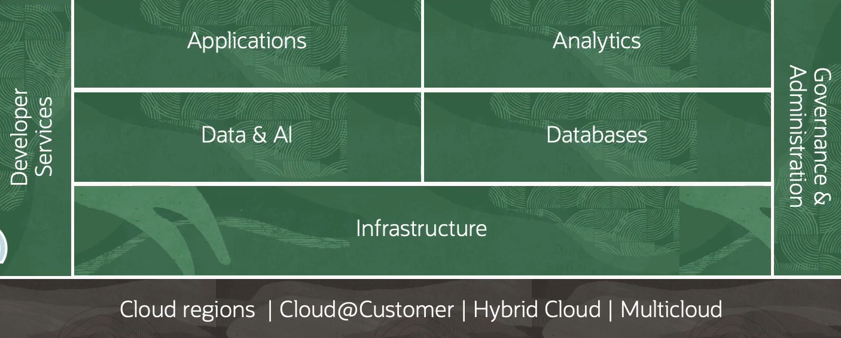
At the very bottom, we have the core primitives-- compute, storage, and networking.
Compute services cover virtual machines, bare metal servers, containers, a managed Kubernetes service, and a managed VMware service. These services are primarily for performing calculations, executing logic, and running applications. Cloud storage includes disks attached to virtual machines, file storage, object storage, archive storage, and data migration services.
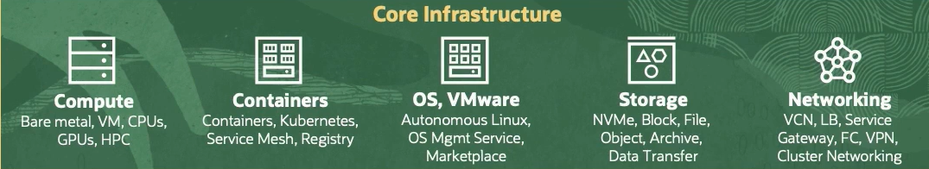
OCI offers a complete range of storage services for you to store, access, govern, and analyze your structured or unstructured data. Networking features let you set up software to find private networks in Oracle cloud. OCI provides the broadest and deepest set of networking services with the highest reliability, most security features, and, of course, highest performance.
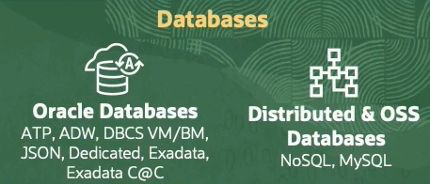
Then we have database services. We have multiple flavors of database services, both Oracle and open source. OCI runs multiple flavors of autonomous database, including Transaction Processing, or ATP; Data Warehousing, or ADW; and JSON, or AJD. You can get started using autonomous databases for free using our Always Free services. You can even download the autonomous database free container image and run it locally. And then you can run databases and virtual machines, bare metal servers, or even Exadata in the Cloud. You can also run open source databases like MySQL, NoSQL in the Oracle Cloud Infrastructure.
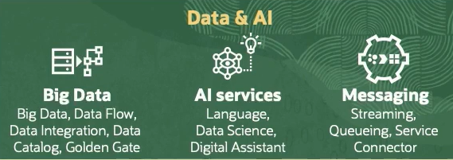
Data and AI services include a generative AI service. It is equipped with advanced language comprehension to build the next gen of enterprise applications. We have a managed Apache Spark service called Data Flow, a managed service for tracking data artifacts across OCI called Data Catalog, and a managed service for data ingestion and ETL called Data Integration. We also have a managed data science platform for machine models and training. We also have a managed Apache Kafka service for event streaming use cases.
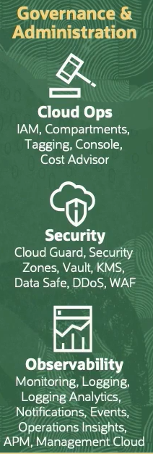
Then we have governance and administration services. These services include security, identity, and observability and management. We have unique features, such as compartments, that make it operationally easier to manage large and complex environments. Security, of course, is integrated into every aspect of OCI, whether it's automatic detection or remediation, what we typically refer as cloud security posture management, robust network protection, or encryption by default. We have an integrated observability and management platform with features like logging, logging analytics, and application performance management, and much more.
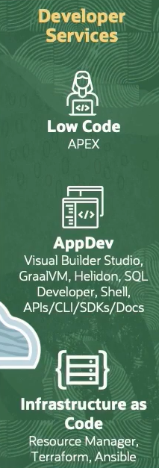
Then we have a bunch of developer services. We have a managed low-code service called APEX, several other developer services, and a managed Terraform service called Resource Manager. For analytics, we have a managed analytics service called Oracle Analytics Cloud, or OAC, that integrates with various third-party solutions.
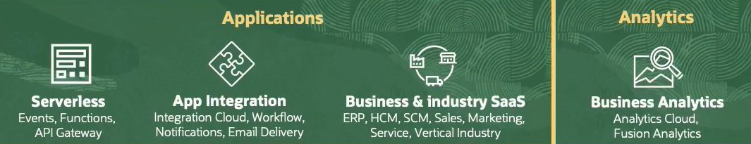
Under application services, we have a managed serverless offering called Functions and API gateway and an event service to help you create microservices and event-driven architecture. We have a comprehensive connected SaaS suite across your entire business, finance, HR, supply chain, manufacturing, advertising, sales, customer service, and marketing-- all running on OCI.
That's a long list. And these seven categories and the services mentioned represent just a small fraction of more than 80 services currently available in OCI. Fortunately, it's quick and easy to try out a new service using our industry-leading free tier account. We are the first cloud to offer a server for just a penny per core hour.
So whether you're starting with OCI or migrating your entire data set into it, we can support you in your journey to the Cloud. That's it. OCI, a broad and deep cloud platform.
--------------------------------------------------
Quiz
